Project 3 MINIX

Modification of the TTY driver
The console at the login screen is in non-canonical mode.
I added a finite state machine for this problem. CTRL+Y will take the user to editing mode. Following a number pressed on the keyboard, the user will be able to move back n spaces to insert their word. CTRL+T will shift the input back to the last ASCII written on the line.

See next page for pseudoCode of the FSM.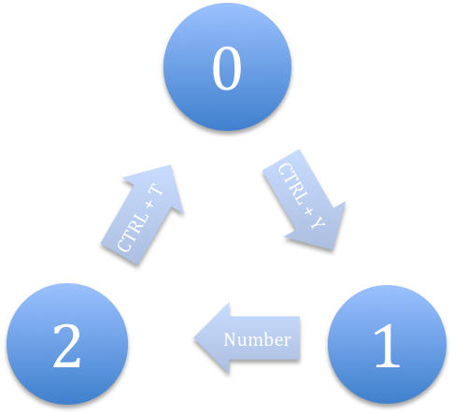
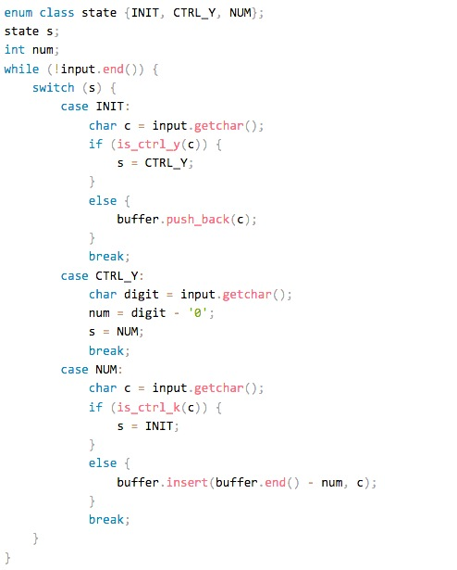
Pseudo-code that is translated into C code in file tty.c, function in_process.
Notes:
1. Take a look at the constant IN_CHAR defined in tty.h. You have to 'logical and' (&) that with "ch" to get the hex value, since "ch" has flags in its upper bits. Then, you have to subtract '0'. I refer you to: http://www.unix-manuals.com/refs/misc/ascii-table.html
2. In MINIX:
-An interrupt in the keyboard calls the System Task which passes a message to the Keyboard Device Driver
-handle_events calls kb_read (line 15360 in the book).
-Kb_read keeps track of keyboard codes that indicate pressing or releasing of ctrl, shift, and alt. This converts scan codes to ASCII codes. On a CTRL, a -1 is returned on line 15385, which is somehow later on processed to return the full ch in kb_read's while-loop.
- kb_read calls in_process which processes the ASCII codes.

3. Pseudocode for actual State 2:
tty_incount++;
int i = 0;
while (num + i > 0) {
tty_inhead[i] = tty_inhead[i - 1]; i--;
}
tty_inhead[-num] = c;
tty_inhead++;

I used rawecho(tp, ‘\b’) to erase each character from the screen and re-wrote them back from a temporary buffer.

Problem 2:
In alloc.c, we will refer to the following struct:
24 PRIVATE struct hole {
25 phys_clicks h_base; /* where does the hole begin? */
26 phys_clicks h_len; /* how big is the hole? */
27 struct hole *h_next; /* pointer to next entry on the list */ 28 } hole[NR_HOLES];
Source: http://www.cise.ufl.edu/~cop4600/cgi-bin/lxr/http/source.cgi/mm/alloc.c#L28

Iterate through the entire hole struct, recoding the biggest h_len, and its corresponding h_base. I stored these values in a temporary array.

Since we set register struct hole *hp to the global tracking variable hole_head, set hp->h_base and hp->h_len to the values found.

Testing:
Files modified:
servers/pm/misc.c
servers/pm/proto.h
servers/is/dmp_pm.c
servers/pm/alloc.c (Again...)
include/minix/type.h (You may also use sys/types.h.)

1. I need a function inside alloc.c that will copy the holes array to an output parameter, which will be of type struct hole *. I also needed to know the size of that struct, and so I need a second output parameter that is also a pointer to an unsigned integer.

2. I need a case inside the switch inside do_getsysinfo. I called it SI_HOLE.
This case will call the function you defined in alloc.c to get a copy of the holes struct to the local copy you have in do_getsysinfo.

3. Declared this function in proto.h.
4. I declared the local holes struct in do_getsysinfo as static. This initializes the fields to default values.

4. Set src_addr and len properly. By the way, to get the size of a struct (not a pointer to a struct, but the struct itself), you do sizeof(the structure's name).

5. In dmp_pm.c, call getsysinfo with parameters PM_PROC_NR, SI_HOLE, and the address of the holes struct.

Basically, I have a holes struct in dmp_pm.c. I pass its address to do_getsysinfo. Do_getsysinfo passes that address to the function in alloc.c. alloc.c sets hole to that address and it goes back up the chain. I used chmem to change the stack size of programs in the sh shell scrip found under the worst_fit folder.

